Relative Layout

The relative layout is used to arrange the child views in a proper order which means arranging the child objects relative to each other.

RelativeLayout Attributes
Sr.No. | Attribute & Description
1 | android:id  This is the ID which uniquely identifies the layout.
2 | android:gravity  This specifies how an object should position its content, on both the X and Y axes. Possible values are top, bottom, left, right, center, center_vertical, center_horizontal etc.
3 | android:ignoreGravity  This indicates what view should not be affected by gravity.
4 | android:layout_above  Positions the bottom edge of this view above the given anchor view ID and must be a reference to another resource, in the form "@[+][package:]type:name"  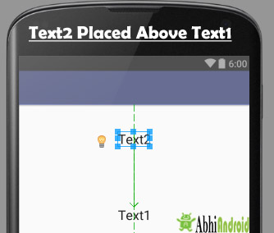
5 | android:layout_alignBottom  Makes the bottom edge of this view match the bottom edge of the given anchor view ID and must be a reference to another resource, in the form "@[+][package:]type:name".  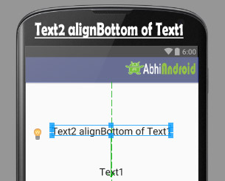
6 | android:layout_alignLeft  Makes the left edge of this view match the left edge of the given anchor view ID and must be a reference to another resource, in the form "@[+][package:]type:name".  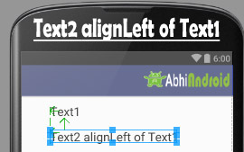
7 | android:layout_alignParentBottom  If true, makes the bottom edge of this view match the bottom edge of the parent. Must be a boolean value, either "true" or "false".  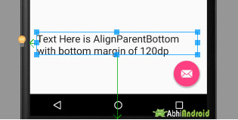
8 | android:layout_alignParentEnd  If true, makes the end edge of this view match the end edge of the parent. Must be a boolean value, either "true" or "false".  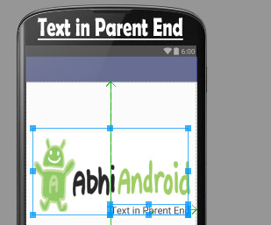
9 | android:layout_alignParentLeft  If true, makes the left edge of this view match the left edge of the parent. Must be a boolean value, either "true" or "false".  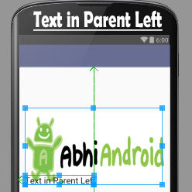
10 | android:layout_alignParentRight  If true, makes the right edge of this view match the right edge of the parent. Must be a boolean value, either "true" or "false".  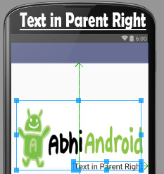
11 | android:layout_alignParentStart  If true, makes the start edge of this view match the start edge of the parent. Must be a boolean value, either "true" or "false".  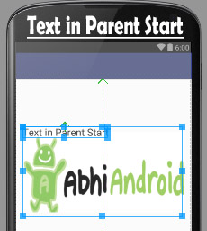
12 | android:layout_alignParentTop  If true, makes the top edge of this view match the top edge of the parent. Must be a boolean value, either "true" or "false".  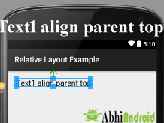
13 | android:layout_alignRight  Makes the right edge of this view match the right edge of the given anchor view ID and must be a reference to another resource, in the form "@[+][package:]type:name".  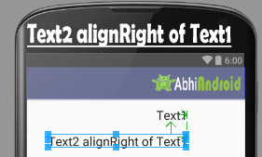
14 | android:layout_alignStart  Makes the start edge of this view match the start edge of the given anchor view ID and must be a reference to another resource, in the form "@[+][package:]type:name".  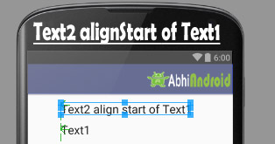
15 | android:layout_alignTop  Makes the top edge of this view match the top edge of the given anchor view ID and must be a reference to another resource, in the form "@[+][package:]type:name".  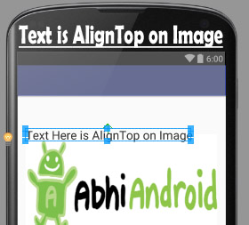
16 | android:layout_below  Positions the top edge of this view below the given anchor view ID and must be a reference to another resource, in the form "@[+][package:]type:name".
17 | android:layout_centerHorizontal  If true, centers this child horizontally within its parent. Must be a boolean value, either "true" or "false".  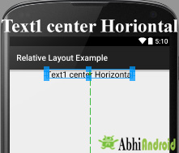
18 | android:layout_centerInParent  If true, centers this child horizontally and vertically within its parent. Must be a boolean value, either "true" or "false".  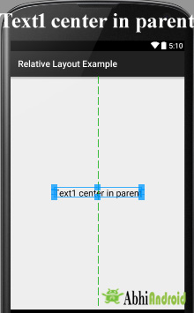
19 | android:layout_centerVertical  If true, centers this child vertically within its parent. Must be a boolean value, either "true" or "false".  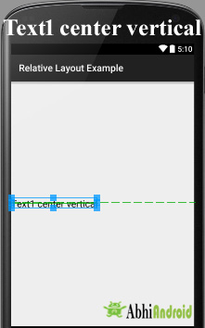
20 | android:layout_toEndOf  Positions the start edge of this view to the end of the given anchor view ID and must be a reference to another resource, in the form "@[+][package:]type:name".
21 | android:layout_toLeftOf  Positions the right edge of this view to the left of the given anchor view ID and must be a reference to another resource, in the form "@[+][package:]type:name".
22 | android:layout_toRightOf  Positions the left edge of this view to the right of the given anchor view ID and must be a reference to another resource, in the form "@[+][package:]type:name".
23 | android:layout_toStartOf  Positions the end edge of this view to the start of the given anchor view ID and must be a reference to another resource, in the form "@[+][package:]type:name".

e.g.
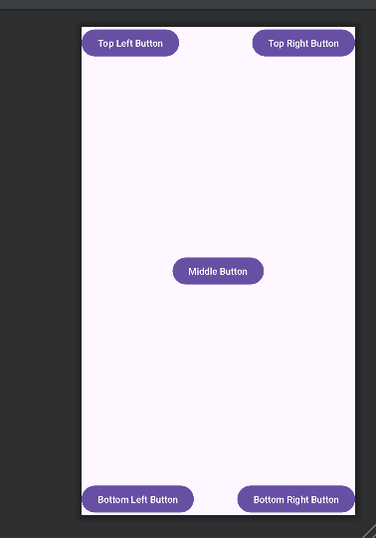
Padding: in Android is used to add a blank space between a view and its contents.
android:padding="11dp"
android:paddingLeft="11dp" …………..
Margins, on the other hand, are used to add a space between two different views. The following illustration will help to clarify the difference between the two:
e.g.
android:layout_margin="222dp"
android:layout_marginLeft="222dp"………….
